Lab # 14
Conversion of fuzzy set to crisp set using membership functions

Objectives:
- To understand difference between characteristic function and crisp function
- To learn about Fuzzy system and membership functions
- To implement different membership functions to convert Fuzzy set to crisp set
Lab Related Theory:
Fuzzy Systems
A fuzzy inference system (FIS) is a nonlinear mapping of input feature vectors to a scalar output [Mendel, 1995]. It consists of four components: Fuzzifier, Rules, Inferences and Defuzzifier.
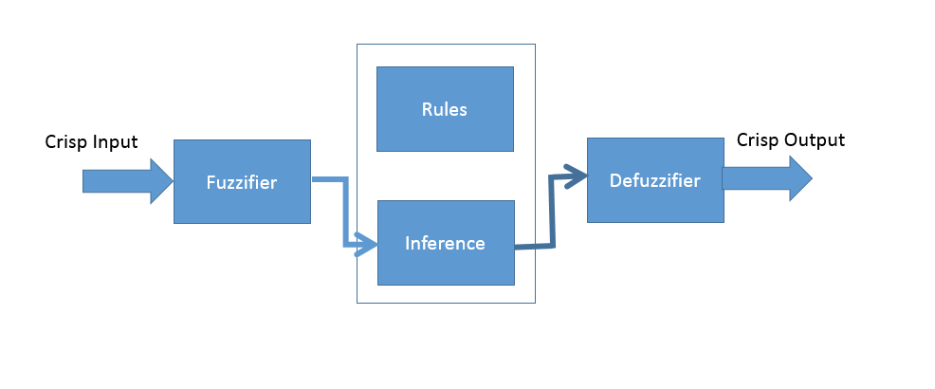
Membership Functions
Fuzzifier
It converts the crisp input to fuzzy inputs (sets). In general if 'x' is crisp input, we apply a function (membership function) f:x --> y There are various types of membership functions:
Triangular Membership Function
Here we have a triangular curve, mapping x, based on three values a,b,c. 'a' and 'c' are the feet of the triangle on the x-axis, and 'b' is the peak of the triangle. Mathematically, the function is defined as:
f(x;a,b,c)= 0 ∀ x ≤ a
^{(x-a)} / _{(b-a)} ∀ a < x ≤ b
^{(c-x)} / _{(c-b)} ∀ b < x < c
0 ∀ x ≥ c
Trapezoidal Membership Function:
The function depends on four parameters a,b,c and d. The parameters 'a' and 'd' determine the feet of the trapezoid, while parameters 'b' and 'c' determine the shoulders of the trapezoid. Mathematically we define it as:
f(x;a,b,c)= 0 ∀ x ≤ a
^{(x-a)} / _{(b-a)} ∀ a < x ≤ b
1 ∀ b < x < c
^{(d-x)} / _{(d-c)} ∀ c < x < d
0 ∀ x ≥ d
Symmetric Gaussian Membership Function
Symmetric Gaussian function is defined by two parametrs, s and v. Mathematically it is defined as:
f(x;s,v) = e ^{-(x-v)2}/2c²
Code : To Demonstrates the use of Fuzzifier module to make a trapezoidal membership function
import fuzzifier
import matplotlib.pyplot as plt
import numpy as np
# Demonstrates the use of Fuzzifier module to make a trapezoidal membership function
x=np.arange(0, 10.1, 0.5)
low=np.array([0,2,3,4])
middle=np.array([3,4,5,6])
high=np.array([5,8,9,10])
service=fuzzifier.Trapezoid(x,low,middle,high)
plt.plot(x, service.low, x, service.middle,x,service.high)
plt.ylabel('Service')
plt.xlabel(' x ')
plt.axis([0, 10, -0.1, 1.1])
plt.grid(True)
plt.show()

Reference: https://github.com/amita-kapoor/Python-Fuzzy
Lab Tasks:
- Write a code to implement triangular membership function. Plot the figure.[Note: You will have to edit code2 of lab manual]

Learning Outcomes:
In this lab we implement different membership functions to convert Fuzzy set to crisp set

learn about Fuzzy system and membership functions

